1. Iterative deepening depth-first search (**IDDFS**) is a state space search strategy in which a depth-limited search is run repeatedly, increasing the depth limit with each iteration until it reaches d, the depth of the shallowest goal state. Implement this search algorithm and test them on following graph and print the Search sequence (***A*** is the ***start*** state and ***N*** is the ***goal*** state).

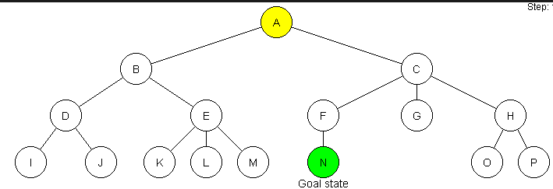

1. Implement ***A\**** search algorithms and test them on following graph and print the Search sequence (***Heuristic: Euclidian Distance***).

